**Deerwalk Institute Of Technology**

**Database Administration**

**Lab: 2**

**Submitted By: Submitted To:**

**Name: Sagar Giri Narayan Chalise**

**Roll No. 205**

**Date:**

**DATABASE CREATION**

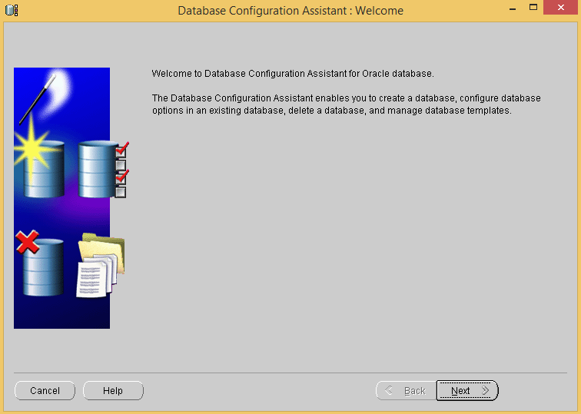

**Fig: Database Configuration**

First, a welcome message is seen from Oracle database. Click Next to continue.

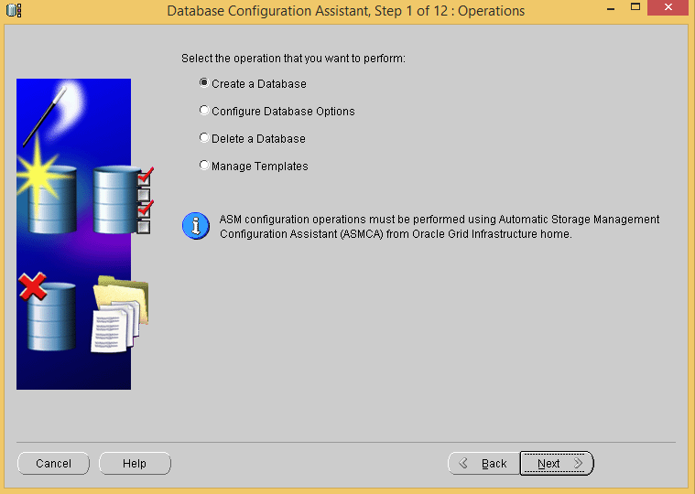

**Fig: Step 1 – Operations**

Then, We have to select the operation C**reate a Database** and click next to continue.

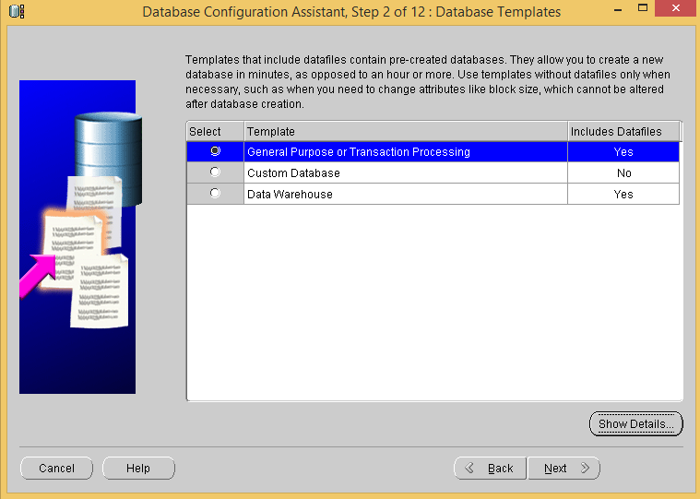

**Fig: Step 2 – Database Templates**

After creating a database, we can use templates as **General Purpose or Transaction Processing** Templates.

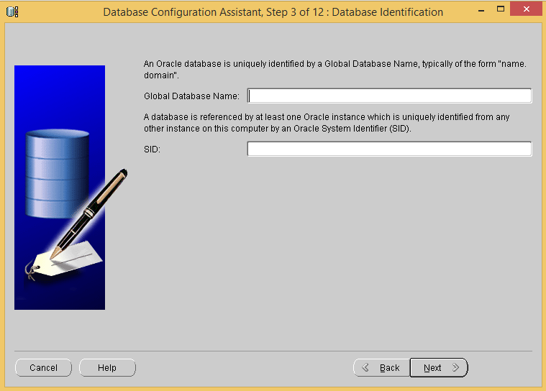

**Fig: Step 3 – Database Identification**

Then, an oracle database is uniquely identified by a global database name and the database is referenced by at least one Oracle instance, which is uniquely identified from any other instance on the computer by an Oracle System Identifier (SID).

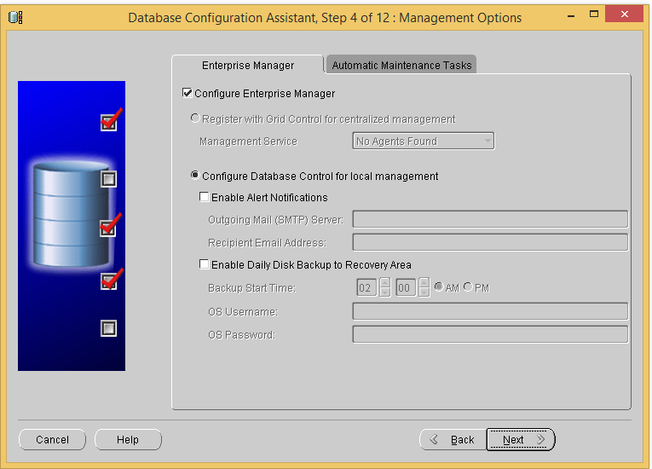

**Fig: Step 4 – Management Options**

Then, check on **Configure Enterprise Manager** and Click Next to Continue.

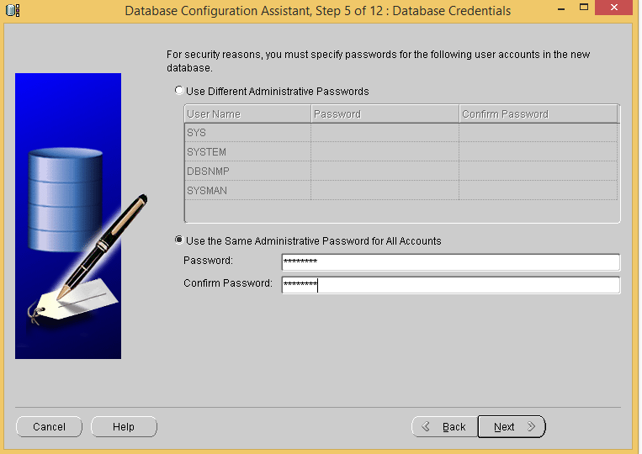

**Fig: Step 5 – Database Credentials**

Then, the user credentials is given for the security purpose. A new administrative user is create with strong password and clicked next to continue.

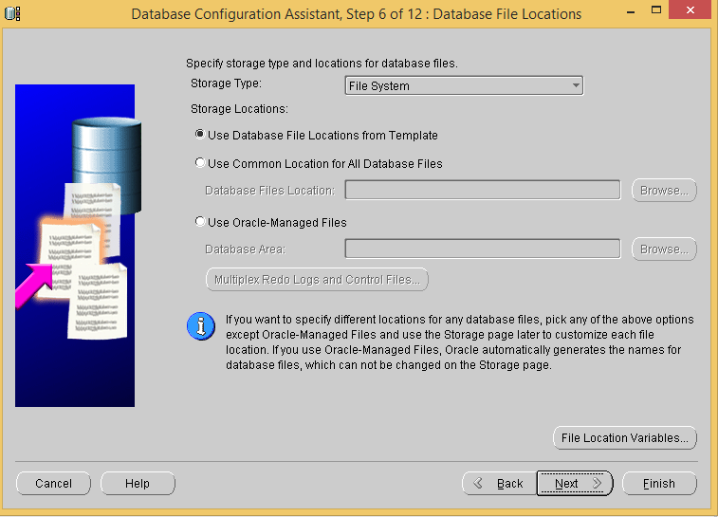

**Fig: Step 6 – Database File Locations**

Then the locations of the database file is given and the locations are detected from the template.

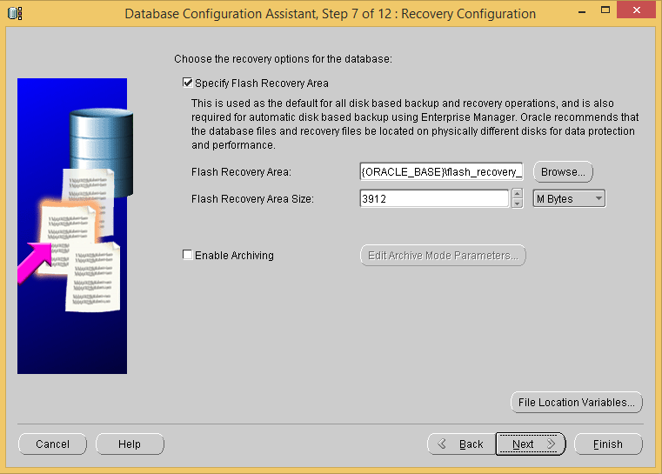

**Step 7 – Recovery Configuration**

The recovery options for the database is chosen and as per the recovery at future the database can be recovered.

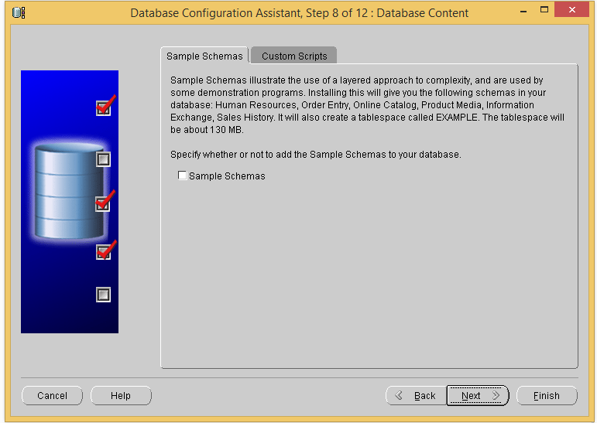

**Fig: Step 8 – Database Content**

The database contents are managed.

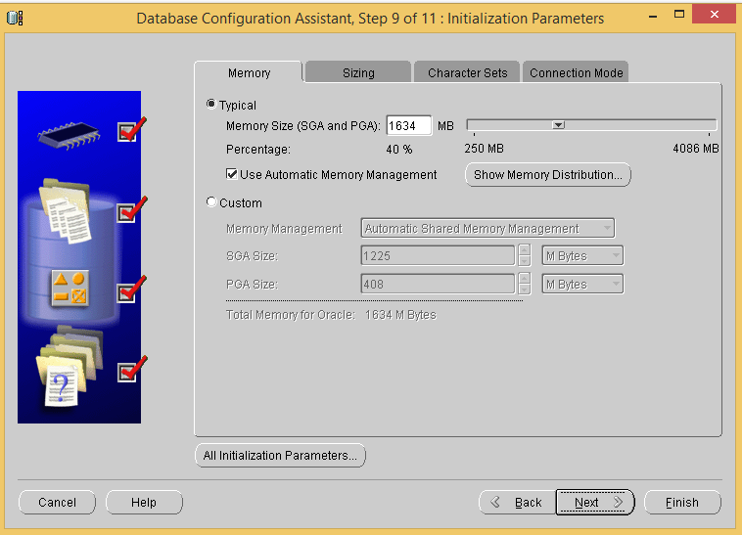

**Fig: Step 9 – Initialization Parameters**

The parameter of the memory or the machine is given in order to function the software properly and the automatic memory management is checked so as to manage the requirement available in computer.

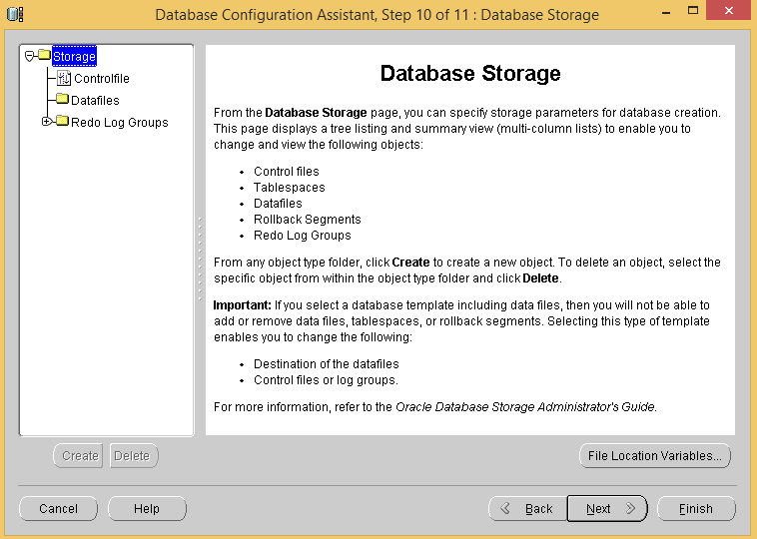

**Fig: Step 10 – Database Storage**

The storage page specifies the storage parameters for database creation.

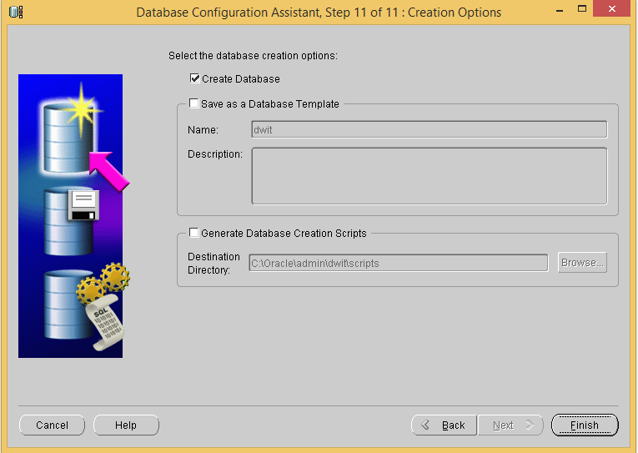

**Fig: Step 11 – Creation Options**

Finally, the database is created and click Finish to Successfully install the database.

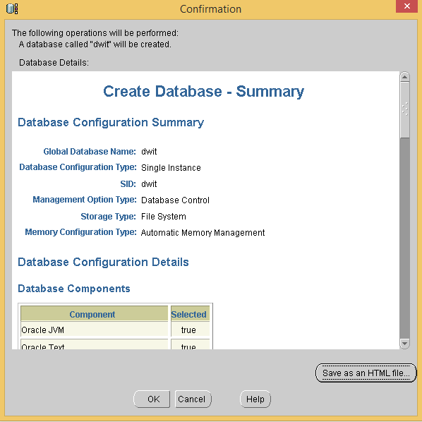

**After installation summary report.**

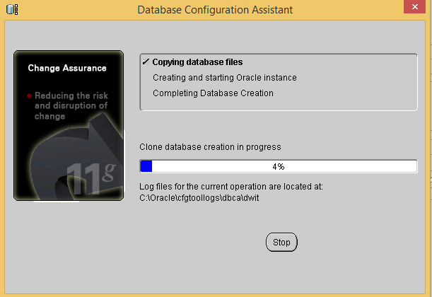

Finally, the database will clone the creation of database and different queries are done.